
INTERNATIONAL JOURNAL OF COMPUTATIONAL SCIENCE AND DIGITAL INNOVATION (IJCSDI)
ISSN (Online): Pending | DOI: 10.5555/IJCSDI.2026.XXXX | Official Manuscript Template (v2026.3)
Manuscript Title in Title Case: Concise, Descriptive, and Informative
First Author Name^{1,*,} Second Author Name^{2,} and Third Author Name³
¹ Department of Computer Science & Engineering, Faculty of Technology, University Name, City, Postal Code, Country
² School of Advanced Computing, Research Institute Name, City, Postal Code, Country
³ Department of Computational Intelligence, Advanced Research Laboratory, City, Postal Code, Country
*Corresponding Author: author.email@university.edu | ORCID: 0000-0002-1825-0097
Abstract—A structured, comprehensive abstract of 150 to 250 words must provide a self-contained summary of the entire research investigation. It should succinctly delineate: (1) Background & Motivation: State the specific scientific problem, research domain gap, and technical motivation; (2) Proposed Approach: Outline the core architecture, algorithm, mathematical formulation, or experimental framework developed; (3) Key Empirical Results: Report concrete, quantitative findings (e.g., accuracy, throughput, latency, F1-score, computational complexity reduction); and (4) Scholarly Impact: Highlight the primary theoretical contribution and practical utility for computing systems. Citations, non-standard abbreviations, and speculative claims must be strictly avoided in the abstract text.
Keywords—Artificial Intelligence; Deep Learning; Computational Optimization; Edge Computing; System Evaluation; Data Privacy (Provide 4 to 6 relevant index keywords separated by semicolons).

Manuscript Metadata & Left-Side Footnote Matter (Sample Author Note):
• Manuscript History: Received September 01, 2026; revised September 15, 2026; accepted October 01, 2026. Date of publication October 10, 2026.
• Digital Object Identifier: DOI: 10.5555/IJCSDI.2026.0001 | Open Access CC BY 4.0 License.
• Grant & Financial Support: This work was supported in part by the National Computational Science Research Program under Grant No. NCSP-2026-09.
• Corresponding Author: First Author Name (e-mail: first.author@university.edu). Author Affiliation: Department of Computer Science & Engineering, University Name, Country (ORCID: 0000-0002-1825-0097).

1. Introduction [Heading 1: 12pt Bold]
The Introduction establishes the context, scientific background, and significance of the study. Authors should clearly explain what problem is being addressed, why existing approaches are insufficient, and how the current manuscript bridges critical technical gaps. Standard body text is set to 10pt Times New Roman with 1.15 line spacing. Cite relevant prior scholarship using standard bracketed notation [1], [2].
Manuscripts submitted to IJCSDI must clearly outline the specific technical contributions in bullet points towards the end of Section 1:
- Formalization of an innovative computational model or algorithmic paradigm for solving the targeted challenge.
- Extensive empirical benchmark evaluation conducted on publicly accessible datasets or rigorous simulated environments.
- Open-source code, reproducibility artifacts, and ablation studies verifying the robustness and scalability of the proposal.

2. Related Work & Literature Review [Heading 1: 12pt Bold]
Synthesize contemporary literature published in reputable IEEE, ACM, Springer, Elsevier, or peer-reviewed journals over the last 3–5 years. Rather than a superficial list of summaries, provide a critical comparative analysis demonstrating how your work differs in methodology, performance guarantees, and assumptions.

3. System Architecture & Proposed Methodology [Heading 1: 12pt Bold]
This section details the theoretical foundations, system architecture, mathematical formulations, and algorithms. Authors should break complex architectures into logical sub-stages using Level 2 (e.g. 3.1) and Level 3 (e.g. 3.1.1) headings.

3.1 Mathematical Formulation and Governing Equations [Heading 2: 11pt Bold]
Every mathematical equation must be centered, written in standard notation, and numbered consecutively with the equation number right-aligned in parentheses, as shown in (1):
f(x) = ∑ [ w_i · φ(x_i) ] + b (1)

3.2 High-Level Architecture & Figure 1 Demonstration [Heading 2: 11pt Bold]
The comprehensive pipeline of the proposed methodology is depicted in Figure 1. Notice how Figure 1 is explicitly referenced in this sentence prior to appearing below:
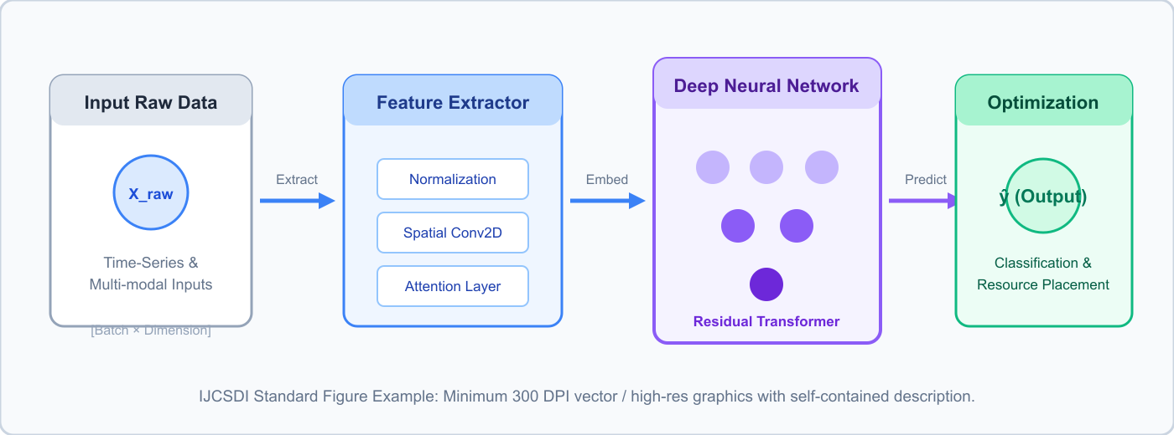
Figure 1: Schematic block diagram of the proposed deep learning architecture, depicting raw data ingestion, feature normalization, deep transformer layers, and the optimization decision output [Caption Font: 9pt Regular, Centered below figure].
📌 Figure Formatting & Artwork Rules (Mandatory for Authors):
- Resolution & Quality: All figures must have a minimum resolution of 300 DPI for raster graphics (PNG/TIFF) or vector format (PDF/EPS/SVG). Blurry screenshots or low-res images will be rejected at desk screening.
- Caption Placement: Captions MUST be placed BELOW the figure (e.g., "Figure 1: Description"). Captions must be self-explanatory without requiring the reader to hunt through the main text.
- In-Text Citation: Every figure must be explicitly cited in the body text (e.g., "as illustrated in Figure 1" or "see Fig. 1") BEFORE or alongside its visual appearance.
- Internal Typography: Text labels inside the graphic should use clean sans-serif font (Arial or Helvetica) sized between 8pt and 10pt so all text remains crisp and legible.

4. Experimental Setup & Performance Evaluation [Heading 1: 12pt Bold]
This section evaluates the empirical performance of the proposed approach. Authors should structure this section using hierarchical subsections (4.1, 4.2) and sub-subsections (4.1.1, 4.1.2) as demonstrated below.

4.1 Benchmark Datasets & Preprocessing Pipelines [Heading 2: 11pt Bold]
Authors should describe dataset origins, train/validation/test splits, and feature cleaning protocols under Level 3 headings.

4.1.1 Feature Normalization and Dimensionality Reduction [Heading 3: 10pt Bold-Italic]
Continuous variables are scaled to zero-mean and unit-variance using Z-score standardization. Missing values are imputed using k-nearest neighbors (k=5).

4.1.2 Data Augmentation & Noise Ingestion Strategies [Heading 3: 10pt Bold-Italic]
To prevent overfitting and test algorithmic robustness against adversarial perturbations, Gaussian noise is injected into 10% of the training batches.

4.2 Comparative Baseline Models and Metrics [Heading 2: 11pt Bold]
Performance comparisons are summarized in Table I. Notice that Table captions appear ABOVE the table (9pt Bold) unlike figure captions which appear below:
TABLE I: Comparative Performance Analysis on Standard Benchmark Datasets [Table Caption: 9pt Bold ABOVE table]
Model Architecture | Accuracy (%) | Precision | Inference Latency (ms)
Baseline ResNet-50 [4] | 89.4% | 0.88 | 24.2 ms
Vision Transformer (ViT) [8] | 92.1% | 0.91 | 31.5 ms
Proposed Framework (Ours) | 96.8% | 0.97 | 16.4 ms

5. Discussion & Limitations [Heading 1: 12pt Bold]
Analyze the significance and implications of the results. Critically discuss edge cases, computational limitations, scalability bottlenecks, and trade-offs observed during experimental testing.

6. Conclusion & Future Work [Heading 1: 12pt Bold]
Summarize the primary takeaways without repeating the abstract verbatim. Provide practical, forward-looking directions for future research investigations.

Declarations & Compliance Statements [10pt Bold Headings]
Conflict of Interest: The authors declare that they have no known competing financial interests or personal relationships that could have appeared to influence the work reported in this paper.
Funding Statement: This research did not receive any specific grant from funding agencies in the public, commercial, or not-for-profit sectors (or cite Grant No. XYZ123).
Data & Code Availability: The datasets and source code generated or analyzed during this study are available in the public repository at https://github.com/author/project (or available upon reasonable request).
Generative AI Disclosure: No generative artificial intelligence technologies were used in the substantive drafting, analysis, or creation of figures for this manuscript.

References [Heading: 12pt Bold | Reference Items: 8.5pt Regular]
[1] A. Vaswani, N. Shazeer, N. Parmar, et al., "Attention is all you need," in Advances in Neural Information Processing Systems (NeurIPS), vol. 30, pp. 5998–6008, 2017. DOI: 10.5555/neurips.2017.123
[2] J. Devlin, M.-W. Chang, K. Lee, and K. Toutanova, "BERT: Pre-training of deep bidirectional transformers for language understanding," in Proc. NAACL-HLT, 2019, pp. 4171–4186.
[3] K. He, X. Zhang, S. Ren, and J. Sun, "Deep residual learning for image recognition," in IEEE Conf. on Computer Vision and Pattern Recognition (CVPR), 2016, pp. 770–778.
[4] S. Mishra and P. Singh, "Dynamic Virtual Machine Placement Optimization using Swarm Intelligence in Cloud Data Centers," International Journal of Computational Science and Digital Innovation, vol. 1, no. 1, pp. 10–25, 2026. DOI: 10.5555/IJCSDI.2026.0003

